WEEK 2
Ames Housing Dataset
Data Visualization & Exploratory Analysis
Data source: Ames Housing Uncleaned Dataset
Week 2 focus: Dataset overview, missing values, distributions, relationships, correlation analysis, and categorical comparisons
1. Executive Summary
Week 2 focused on understanding the Ames Housing dataset through exploratory data visualization. The analysis was performed using Python with Pandas, NumPy, Matplotlib, and Seaborn.
The work began with a general inspection of the dataset, including its number of rows and columns, data types, missing values, and basic statistical information. This provided an initial understanding of the structure and quality of the dataset before performing detailed visual analysis.
Several visualization techniques were then applied to study the distributions of important numerical variables, relationships between housing characteristics and SalePrice, correlations among numerical features, and differences across categorical variables. Missing values were also visualized to identify fields that require attention during the data-cleaning stage.
The analysis showed that SalePrice is generally right-skewed, Overall Qual has a strong relationship with SalePrice, and Gr Liv Area has a positive relationship with SalePrice. Significant differences in average house prices were also observed across neighborhoods.

2. Dataset Overview
The first step of the Week 2 analysis was to examine the overall structure of the Ames Housing dataset.
The dataset was inspected using Pandas to identify:
- Number of rows and columns
- Data types of variables
- Missing-value counts
- Basic statistical information
- Numerical and categorical variables
- Initial characteristics of the housing records
This initial inspection provided a baseline understanding of the dataset before applying visualization techniques.
The dataset contains both numerical and categorical variables describing different aspects of residential properties, including house size, construction year, quality, garage characteristics, basement features, neighborhood, house style, and SalePrice.

3. Missing-Value Visualization
Missing values were analyzed before studying the relationships between variables.
The number of missing entries was calculated for each column and visualized using a horizontal bar chart. This made it easier to identify the variables with the highest amount of missing data.
Major observations
- Some housing features contain substantially more missing values than others.
- Missing values are concentrated in particular property-feature columns.
- The visualization provides an initial indication of which variables may require attention during data cleaning.
- Missing values in the Ames dataset should not automatically be interpreted as errors because some missing categorical values may represent the absence of a particular feature.
Missing values by column.
The missing-value visualization therefore served as an important connection between the Week 2 exploratory analysis and the data-cleaning work performed in the following stage.
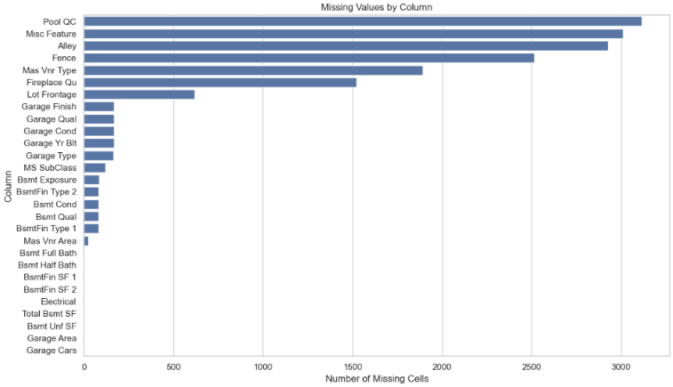

4. Distribution Analysis
Distribution plots were used to understand the characteristics of important numerical variables.
4.1 SalePrice Distribution
A histogram with a density curve was created for SalePrice to examine the distribution of house prices.
The visualization shows that SalePrice is generally right-skewed. Most properties are concentrated within the lower and middle price ranges, while a smaller number of properties have considerably higher prices.
This indicates that the dataset contains relatively expensive properties that extend the distribution toward the higher-price range.
Distribution of SalePrice.
The skewed distribution is important for later analysis because transformations such as logarithmic transformation may be considered when preparing the dataset for statistical or machine-learning applications.
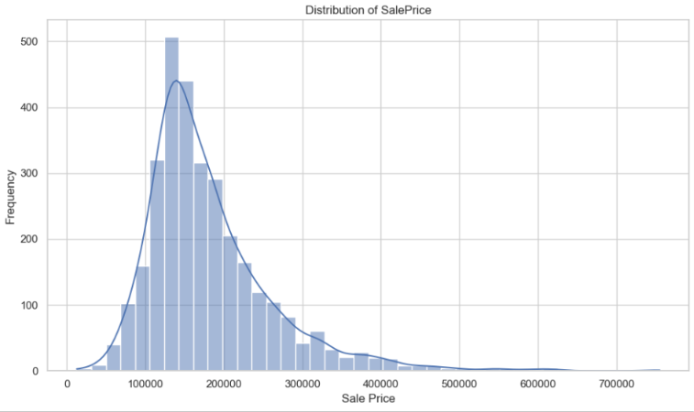
4.2 Year Built Distribution
The distribution of Year Built was visualized to understand when the houses in the dataset were constructed.
The visualization helps identify the concentration of properties around particular construction periods and provides an overall view of the age of the houses.
Distribution of Year Built.
The construction-year distribution can later be used to investigate whether newer or older houses tend to have different SalePrice values.
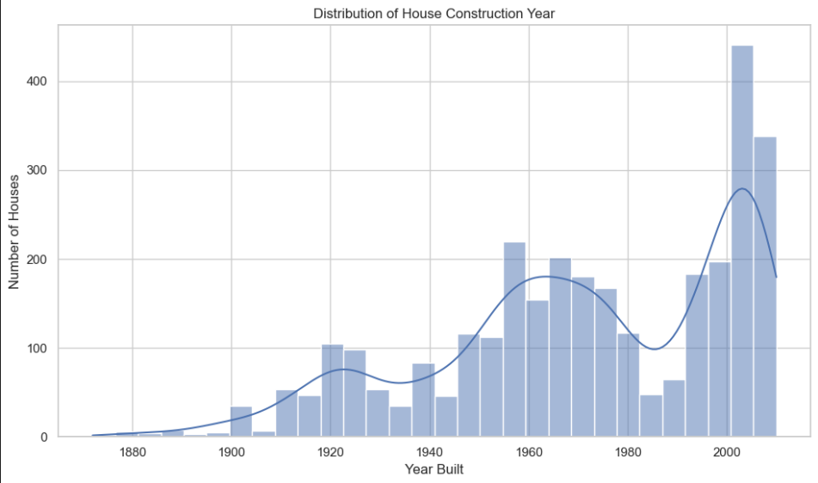
4.3 Gr Liv Area Distribution
The distribution of Gr Liv Area was analyzed to understand the size of the above-ground living spaces.
The visualization shows how living areas are distributed across the properties and helps identify unusually large or small observations.
Distribution of Gr Liv Area.
Gr Liv Area is particularly important because the size of a house is expected to have a relationship with its selling price.
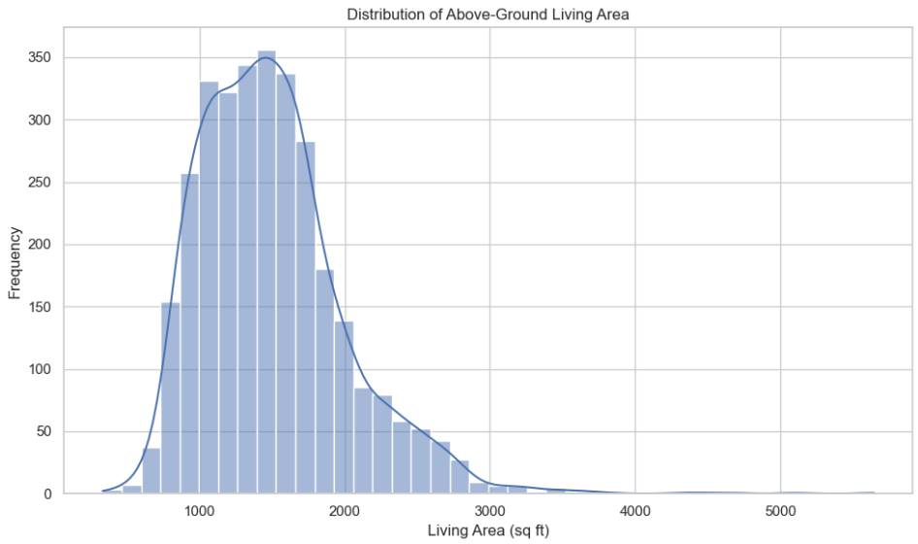
5. Relationship Analysis
The next stage of the visualization focused on understanding relationships between important housing characteristics and SalePrice.
5.1 Overall Quality and SalePrice
A boxplot was used to compare SalePrice across different Overall Qual levels.
Overall Qual represents the overall material and finish quality of the property. The boxplot allows the distribution of SalePrice to be compared for different quality ratings.
The analysis indicates that houses with higher Overall Qual values generally have higher SalePrice values.
This makes Overall Qual one of the most important variables for understanding variations in house prices.
SalePrice across Overall Qual levels.
The increasing pattern across quality levels demonstrates a strong association between the overall quality of a property and its selling price.
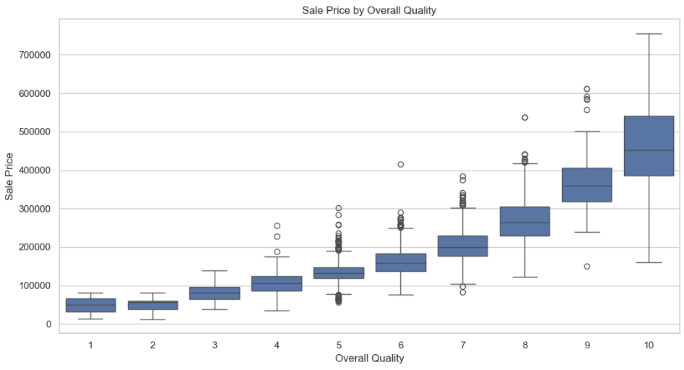
5.2 Gr Liv Area and SalePrice
A scatterplot was created to examine the relationship between Gr Liv Area and SalePrice.
The visualization shows a generally positive relationship between the two variables. In general, properties with larger above-ground living areas tend to have higher SalePrice values.
However, the points do not form a perfectly straight relationship. This indicates that house size is only one of several factors affecting the final selling price.
Other variables such as Overall Qual, Neighborhood, Year Built, garage features, and basement characteristics can also influence SalePrice.
Relationship between Gr Liv Area and SalePrice.
The scatterplot also helps identify potentially unusual observations, such as properties with very large living areas or unusually high or low prices.
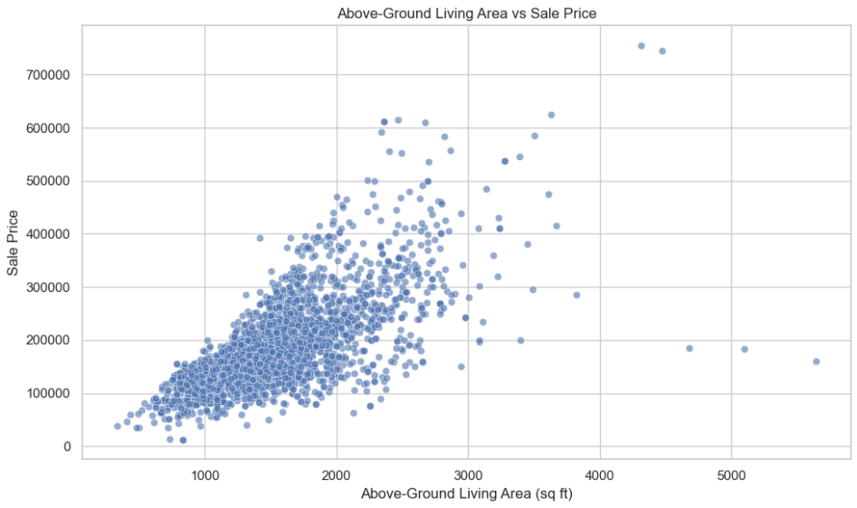
6. Correlation Analysis
A correlation heatmap was generated to examine the relationships among selected numerical variables.
The variables included in the correlation analysis were:
- SalePrice
- Overall Qual
- Gr Liv Area
- Garage Cars
- Garage Area
- Total Bsmt SF
- 1st Flr SF
- 2nd Flr SF
- Year Built
- Year Remod/Add
- Full Bath
- TotRms AbvGrd
The heatmap provides a visual representation of the strength and direction of relationships between these numerical variables.
Correlation heatmap of selected numerical variables.
Key observations
- Overall Qual shows a strong positive association with SalePrice.
- Gr Liv Area has a positive relationship with SalePrice.
- Garage-related variables show positive associations with house price.
- Basement and floor-area variables also show relationships with SalePrice.
- Year Built and Year Remod/Add provide information about the age and modernization of properties.
- Several housing variables are also correlated with one another.
The heatmap therefore provides a compact overview of the numerical relationships that can be investigated further during later analysis.
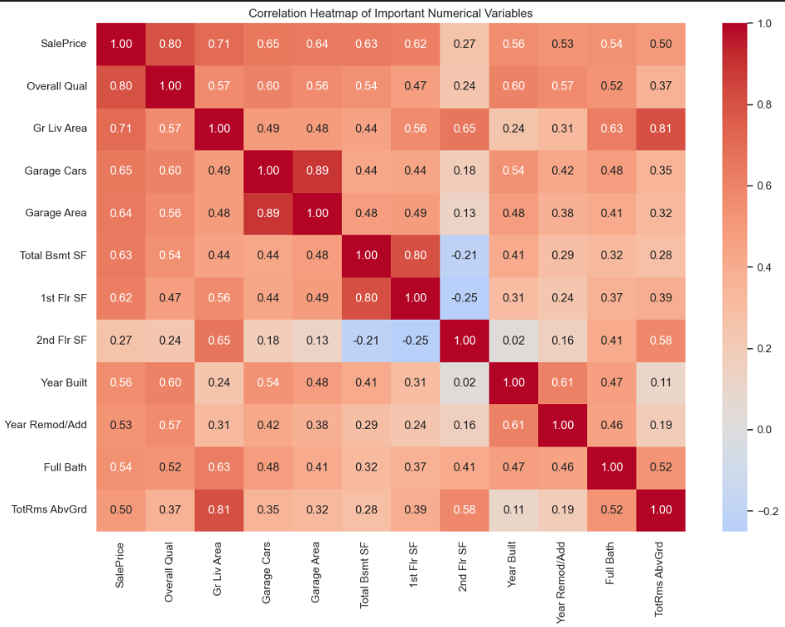
7. Categorical Feature Analysis
Categorical variables were also visualized to understand how different groups of properties compare in terms of SalePrice.
7.1 Average SalePrice by Neighborhood
The average SalePrice was calculated for each Neighborhood and displayed using a bar chart.
Average SalePrice by Neighborhood.
The visualization shows considerable differences in average house prices between neighborhoods.
This indicates that location is an important factor in determining the selling price of a property. Properties located in different neighborhoods can have substantially different average prices even when other characteristics may be similar.
Neighborhood can therefore be considered an important categorical variable for further exploratory and predictive analysis.
7.2 SalePrice by House Style
SalePrice was also analyzed across different House Style categories.
A visualization was created to compare house prices across the different styles represented in the dataset.
SalePrice by House Style.
The comparison helps identify whether particular house styles tend to have different price distributions.
However, differences in house style should be interpreted together with other property characteristics because house style alone does not determine the final selling price.
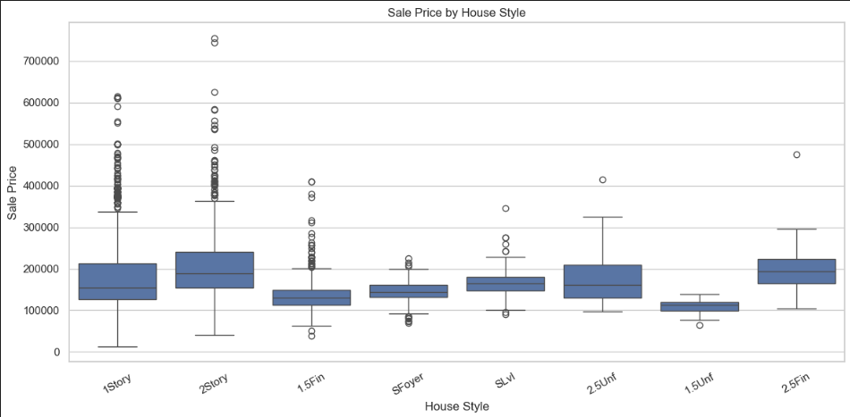
8. Summary of Visualization Findings
The Week 2 visual analysis produced several important observations about the Ames Housing dataset.
Analysis | Main Observation
Missing values | Missing entries are concentrated in specific columns
SalePrice distribution | Generally right-skewed
Year Built | Properties are distributed across different construction periods
Gr Liv Area | Shows variation in property living space
Overall Qual vs SalePrice | Higher quality generally corresponds to higher prices
Gr Liv Area vs SalePrice | Positive relationship between living area and price
Correlation analysis | Several numerical housing features are associated with SalePrice
Neighborhood | Average prices vary considerably between neighborhoods
House Style | Price distributions differ across house-style categories
These observations provide a foundation for more detailed data cleaning and statistical analysis.
9. Importance of the Visualization Stage
The Week 2 visualization stage is important because numerical summaries alone cannot fully reveal the structure of the dataset.
Histograms helped identify the distributions and skewness of numerical variables. Boxplots helped compare SalePrice across quality categories and identify variation within groups. Scatterplots revealed relationships between numerical variables. The correlation heatmap provided an overall view of relationships among important numerical features. Bar charts helped compare average prices across categorical groups.
The visual analysis also helped identify areas that require further attention, including missing values, skewed distributions, potentially unusual observations, and strong relationships between variables.
10. Readiness for Further Analysis
The findings from Week 2 provide a clear direction for subsequent stages of the project.
The main areas identified for further analysis include:
- Handling missing values appropriately.
- Removing or investigating duplicate records.
- Investigating potential outliers.
- Examining skewed numerical variables.
- Performing appropriate transformations where required.
- Studying strong relationships with SalePrice.
- Comparing numerical and categorical features in greater detail.
- Preparing the dataset for further exploratory and predictive analysis.
In particular, the observed right-skewness of SalePrice and the presence of missing values indicate that data cleaning and preprocessing are necessary before advanced analysis.
11. Conclusion
Week 2 provided a visual understanding of the Ames Housing dataset using Python-based exploratory data visualization techniques. The analysis covered the dataset structure, missing values, numerical distributions, relationships with SalePrice, correlations among important variables, and comparisons across categorical features.
The analysis identified several important patterns. SalePrice is generally right-skewed, Overall Qual has a strong association with SalePrice, and Gr Liv Area shows a positive relationship with house prices. Neighborhood-level analysis also revealed considerable differences in average SalePrice, demonstrating the importance of location.
Overall, the visualization stage successfully identified the major patterns and potential data-quality issues in the Ames Housing dataset. These findings provide a foundation for the next stage of the project, where the dataset can be cleaned, transformed, and prepared for deeper exploratory analysis and predictive modeling.

